**Excercise 2 TA features**

**2.2 UML of TA features and 3.2 Own features**

**Ball lock Feature:**

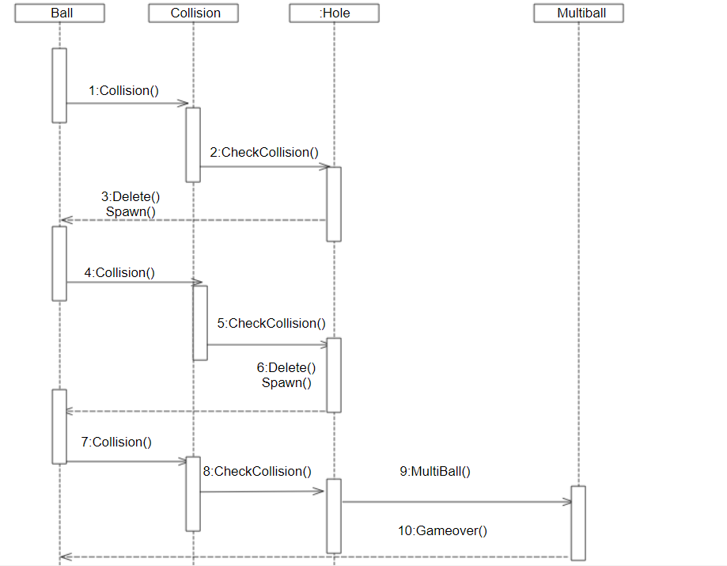

**Extra set Flipper**

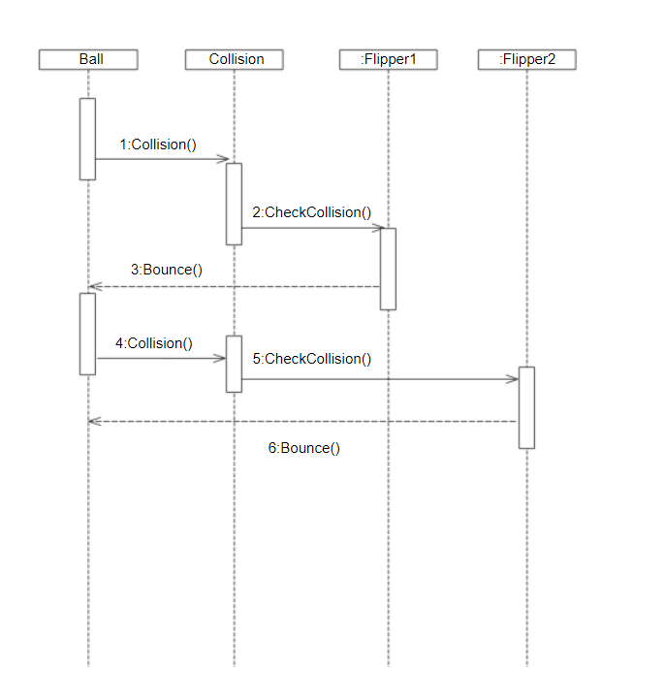

**Jackpot Feature**

